Reluctant star of stem cell research
By Clive Cookson
James Thomson is seeking to solve one of life’s biggest mysteries, why time runs at different rates
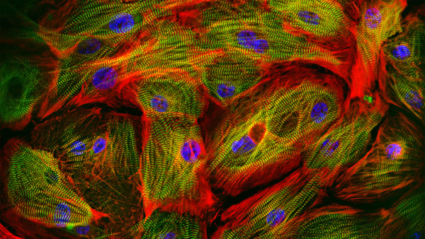
Human heart muscle cells grown from stem cells by Cellular Dynamics International
America’s most celebrated bioscientist around the turn of this century was James Thomson. He was the face of the new stem cell era, which he launched with a landmark experiment at the University of Wisconsin in 1998 – extracting from very early human embryos cells that had the potential to become any specialised tissue in the body.
Unlike some star scientists, Thomson did not enjoy his celebrity. All the media work – covering not only the science but also the ethics of embryonic stem cell research at a time when it was embroiled in controversy – was an unwelcome distraction from his lab experiments. So he has since withdrawn as far as possible from press attention.
Today, away from the spotlight, Thomson remains a leading stem cell scientist with imaginative projects which he outlined to the FT in a rare interview in Chicago. They range from making new human blood vessels and brain tissue to an investigation of the mysterious clock that keeps time in all living cells.
Thomson, 55, is an academic at heart but he also plays a part in commercialising stem cell technology as chief scientific officer of Cellular Dynamics International, a company he co-founded 10 years ago to mass-produce human cells for purposes such as drug discovery and development.
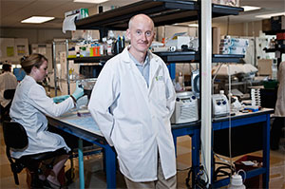
James Thomson
The most important scientific development after the 1998 discovery of human embryonic stem cells (hESCs) came in 2006, when Shinya Yamanaka in Japan converted adult cells into all-purpose stem cells that seemed functionally equivalent to those derived from early embryos. Yamanaka produced these first “induced pluripotent stem cells” or iPSCs from mice, and the following year both he and Thomson achieved the same with human cells. Like most of the world’s researchers, Thomson switched quickly from working with embryonic cells to iPSCs, which are free of ethical constraints and easier to obtain.
He does not foresee a future for embryonic stem cells in mainstream research. “I hate to be the one who says they’re dead,” he says. “There are lingering safety concerns about iPSCs but I think these will disappear over time.”
Thomson says he was beaten to the discovery of iPSCs by Yamanaka, when both were seeking ways to reprogramme adult cells back to an embryonic state, because the Japanese team was using mouse cells which develop about 13 times faster.
“We were using human cells which take months to reach a state that mouse cells reach in a few days. He published way ahead of us but I decided there was no point in feeling annoyed about it for the rest of my life,” he says, in his soft Midwestern accent (he grew up in the Chicago suburb of Oak Park). “Instead I’d work out why time seems to run at such different rates in different species.”
Thomson is searching for an answer to one of life’s biggest mysteries. Several types of biological timekeepers are known. Most familiar is the circadian clock that synchronises the internal rhythm of an organism with the daily cycle of light and dark. Many species also have an annual clock to track the seasons, for the timing of migration, for example, or breeding. But whatever keeps track of cellular development seems to be quite different.
The quest for a fundamental cellular timekeeper has not yet yielded any results or scientific papers. “There must be some sort of clocking mechanism,” Thomson says. “We are looking for oscillators [such as those controlling the circadian clock] but this could well be something quite different.”
Identifying a developmental clock would be enormously significant for biology. “My intuition is that part of what is controlling early timing is related to ageing.”
To fight ageing you might want to slow down the cellular clock – but scientists developing models of human disease will want to speed it up. The specialised cells produced from stem cells today are in effect at a foetal or juvenile stage. For many purposes, such as drug testing, this is fine. But for others, such as modelling degenerative diseases of old age, more mature cells are needed – and researchers cannot wait decades to get them.
Besides this research, Thomson is pursuing projects with more immediate applications. One is part of a programme, funded by several federal agencies, to make better non-animal models for testing new drugs. The Wisconsin contribution is to turn stem cells into a “3D neural construct” (other researchers have called something similar a “mini-brain” but Thomson dislikes the term). “It could be used for neuroscience but I’m interested in making a neural toxicity model that works really well,” he says.
Thomson is also masterminding a project to make blood vessels from iPSCs. The aim is to have something ready to test in monkeys within five years, before making human arteries for use in bypass surgery.
Meanwhile his company CDI, which went public last year, is turning out billions of cells a day in a dozen varieties – with heart and brain cells selling best. Customers, originally drug companies looking for a more sensitive alternative to animal testing, are now appearing from the chemical, cosmetic and food industries. The latest is Nestlé, the world’s biggest food company, wanting to learn more about the health impact of its products.
Elsewhere iPSCs are edging closer to clinical trials. The first is due to start in Japan this year, putting new retinal cells in the eyes of people with macular degeneration. But it is likely to be a decade or more before iPSC-based therapies approach commercialisation.
For Thomson it is too soon to predict the future of stem cells. He compares them with recombinant DNA – genetic manipulation – in the 1970s. “Just as scientists then were given access to DNA for the first time, we are now providing access to human cell lines for the first time,” he says. “We don’t have a crystal ball to show where it is going but we can be confident that some exciting new uses will emerge.”

